++
++9
 AUGUST 7, 2026

EV CHARGING INFRASTRUCTURE
RIP AND REPLACE PROPOSAL
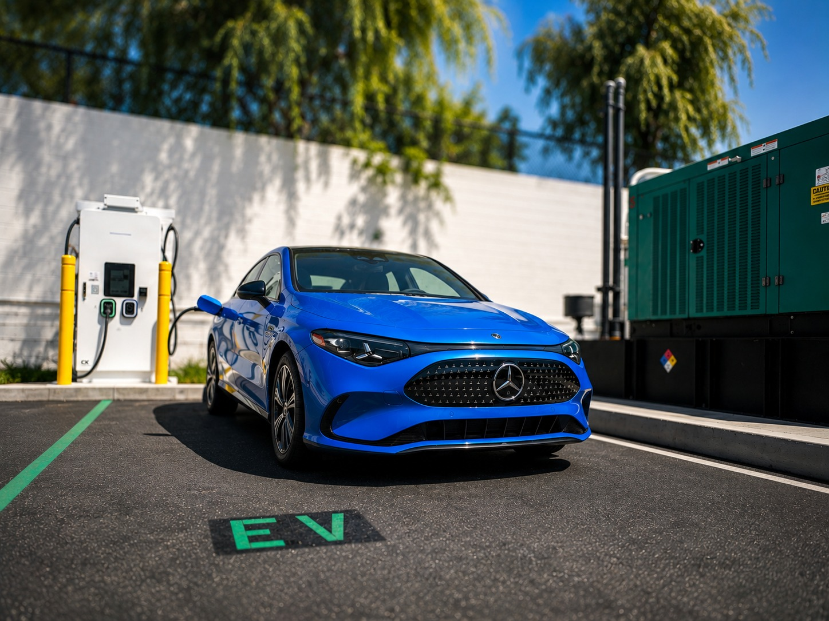
PREPARED FOR  Rolling Hills D-00143  2645 Everett Freeman Way, Corning, CA 96021 | PREPARED BY  Zero Impact Energy  EV Charging Infrastructure Team

Table of contents
Section | Title | Page
1 | Executive Summary
2 | Proposal Overview and Project Information
3 | Historical Usage and Existing Conditions
3A | Full-History Actuals
4 | Revenue Projection Methodology
4A | Key Modeling Assumptions
5 | 5-Year Revenue and Economic Benefit Projection
6 | Proposed Charging Configuration
6A | Charging Equipment Details
7 | Return on Investment
7A | Consolidated 5-Year Cashflow
7B | Charger Revenue Cashflow
8 | Rip and Replace Scope
9 | Electrical and Civil Infrastructure Scope
10 | EVOLV Software and Payment Operations
11 | Operations and Maintenance
12 | Warranty and Service Coverage
13 | Carbon Credits and Environmental Value
14 | Incentives, Tax Benefits and Financing
15 | Project Delivery Plan and Schedule
16 | Detailed Scope of Work
17 | Financing Options
17A | Modeled Monthly Cashflow
17B | 60-Month Financing Cashflow
17C | 60-Month Financing Cashflow
17D | 60-Month Financing Cashflow
18 | Terms, Proposal Validity and Acceptance

1 | EXECUTIVE SUMMARY

Project recommendation
This proposal replaces the existing charging equipment at Rolling Hills D-00143 with none DC fast charging and 15 Level 2 ports. Total project cost is $110,130.09 after discount, against $84,140.89 of modelled charging revenue and $20,585.46 of carbon credits over 5 years. The model does not reach break-even within the 5-year window shown. Financing is available through De Lage Landen at 8.39% over 60 months, a payment of $2,253.65 per month.

The proposed DC fast chargers add North American Charging Standard, also known as NACS or Tesla, connector capability in place of legacy CHAdeMO cables. NACS began broad industry adoption in 2024 and is increasingly standard on new North American EVs. Adding NACS alongside CCS1 improves compatibility with the expanding vehicle mix and positions the site to serve more drivers over the equipment lifecycle.

Proposed solution at a glance
Component | Configuration | Customer value
Level 2 charging | 10 single-port 32A units | More usable ports for longer-dwell customers
DC fast charging | 2 x 120 kW Gen3 + 1 x 60 kW Gen2 | Faster turnover and higher revenue potential
Connectors | CCS1 and NACS capability | Broader compatibility with current and future EVs
Software | EVOLV network, payments and reporting | Operational visibility and revenue control
Service | Five-year service and warranty allowance in model | Defined support path and lifecycle coverage
Delivery | Rip and replace | Reduced disruption and controlled installation scope

2 | PROPOSAL OVERVIEW AND PROJECT INFORMATION

Proposal purpose
This proposal presents a customer-specific modernization plan for the Rolling Hills D-00143 EV charging site at 2645 Everett Freeman Way, Corning, CA 96021. It combines historical operating performance, recommended equipment, project pricing, revenue projections, service coverage, carbon-credit assumptions, financing, delivery scope and commercial terms in one coordinated offer.
Project information
Field | Project information
Client contact
Site | Rolling Hills D-00143
Address | 2645 Everett Freeman Way, Corning, CA 96021
Property type | Retail
Primary users | Customers and public use
Proposal date | August 7, 2026
Proposal version | V1.0
Validity | 30 days from proposal date unless extended in writing
Customer objectives
Commercial priorities  • Attract and retain EV drivers  • Generate charging and ancillary site revenue  • Replace unreliable or obsolete equipment | Infrastructure priorities  • Improve the customer charging experience  • Create a scalable platform for future expansion  • Support sustainability and operational goals
Proposal contents
Section | Topic | Section | Topic
1 | Executive Summary | 10 | EVOLV Software and Payment Operations
2 | Proposal Overview and Project Information | 11 | Operations and Maintenance
3 | Historical Usage and Existing Conditions | 12 | Warranty and Service Coverage
4 | Revenue Projection Methodology | 13 | Carbon Credits and Environmental Value
5 | 5-Year Revenue and Economic Benefit Projection | 14 | Incentives, Tax Benefits and Financing
6 | Proposed Charging Configuration | 15 | Project Delivery Plan and Schedule
7 | Return on Investment | 16 | Detailed Scope of Work
8 | Rip and Replace Scope | 17 | Financing Options
9 | Electrical and Civil Infrastructure Scope | 18 | Terms, Proposal Validity and Acceptance

3 | HISTORICAL USAGE AND EXISTING CONDITIONS

Site history
The site has 30 months of recorded charging activity, Aug 2023 to Jul 2026, totalling $4,075 of revenue. All of it came from Level 2 charging; the site has no DC fast charging history.

35 months  HISTORY REVIEWED  Aug 2023 to Jun 2026 | $4,075  HISTORICAL REVENUE  Level 2 + Level 3 actual | 96%  DC FAST REVENUE SHARE  $0 of total | $0  ESTIMATED OUTAGE LOSS  Jan and Feb 2026

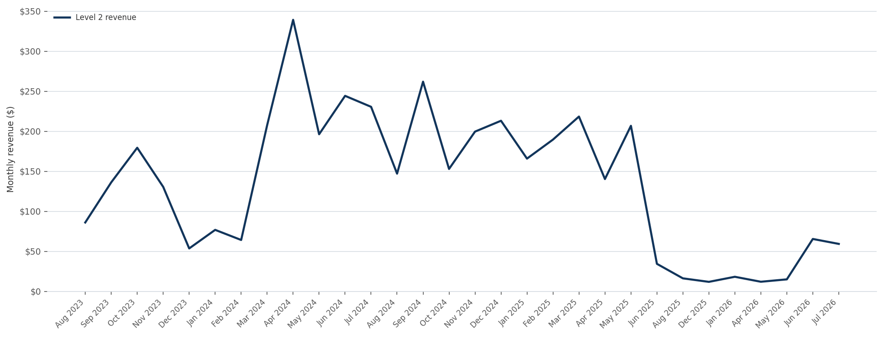
Historical monthly charging revenue, Aug 2023 to Jul 2026

3A | FULL-HISTORY ACTUALS  Continuation of Section 3

FULL-HISTORY ACTUALS (Aug 2023 to Jul 2026) | Level 2 | Level 3
Months in window | 30
Days in window | 1,096
Total revenue | $4,075.35 | $0.00
Total kWh | 14,778.0 | 0.0
Avg revenue per month | $135.84 | $0.00
Avg kWh per month | 492.6 | 0.0
Avg kWh per day | 13.48 | 0.00
Effective retail rate ($/kWh) | $0.276 | $0.000
Avg stalls used per day | 0.955 | 0.000
Avg charging hours per active stall per day | 2.774 | 0.000
Avg delivered power while charging (kW) | 5.09 | 0.00
Total sessions | 1,429 | 0
Sessions per day | 1.30 | 0.00
Avg kWh per session | 10.34 | 0.00
Median kWh per session | 8.09 | 0.00
Sessions delivering <1 kWh (failed/aborted) | 34.4% | 0.0%
Avg charging time per session (min) | 121.91 | 0.00
Est. unproductive station-days (out of service) | 49% | 0%
Avg stalls in service per day (hardware alive) | 15.40 | 0.00
Stall occupancy among IN-SERVICE stalls | 6.2% | 0.0%

4 | REVENUE PROJECTION METHODOLOGY

Forecast structure
Layer | Calculation logic | Client-facing output
1. Historical actual | Observed sessions, kWh, revenue and uptime | Actual baseline with source period
2. Operational normalization | Adjust for dead equipment, outages, failed starts and partial periods | Normalized demand and recoverable usage
3. Proposed configuration | Ports x occupancy x hours x delivered kW x retail price | Projected charging revenue and kWh
4. Operating cost | Projected kWh x utility energy rate plus network and O&M costs | Net operating profit
5. Idle policy | Sessions x overstay share x billable minutes x fee | Separate idle-fee revenue
6. Growth scenarios | Conservative, base and upside assumptions by year | Range, not a single guaranteed forecast
7. Non-operating benefits | Tax incentives, grants and environmental credits | Separate, eligibility-qualified benefit lines

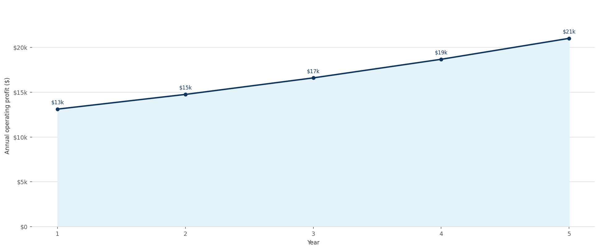
Modeled annual operating profit, Years 1 through 5

4A | KEY MODELING ASSUMPTIONS  Continuation of Section 4

Assumption | Workbook value | Customer-facing treatment
Site operating window | 12 hours per day | Subject to confirmation of actual site access hours
Utility energy cost | $0.40 per kWh | Subject to current tariff and demand-charge review
Level 2 retail price | $0.65 per kWh projected | Subject to final pricing policy and applicable taxes or fees
Level 3 retail price | $0.70 per kWh projected | Subject to final pricing policy and market position
New-equipment downtime | 3% model assumption | Planning assumption, not a contractual service-level guarantee
Annual growth | 12.5% in Years 2 through 5 | Base-case growth assumption used in the model
Idle policy | 60-minute Level 2 / 30-minute Level 3 grace | Subject to final customer-experience and operating policy
MODEL SCOPE: The 10-year total in this proposal includes operating profit, modeled idle fees and the Year 1 federal investment tax credit assumption. It excludes environmental credits and does not subtract project cost.

5 | 5-YEAR REVENUE AND ECONOMIC BENEFIT PROJECTION

$26,870  YEAR 1 OPERATING PROFIT  Charging profit + idle fees | $108,477  YEAR 1 TOTAL INCL. ITC  Includes modeled federal ITC | $406,173  5-YEAR OPERATING PROFIT  Before idle fees | $564,696  5-YEAR TOTAL BENEFIT  Operating profit + idle fees + ITC
Projected new-charger operating profile
Metric | Level 2 | Level 3 (Fast)
Chargers | 15 | 0
EV Stall Quantity (Based on # of ports) | 30 | 0
Max hours of operation of parking | 24 | 24
Stall Occupancy % (stalls seeing use each day) | 20.0% | 20.0%
Number of stalls used per day | 6.00 | 0.00
Charging Hourly % per stall per day | 11.6% | 0.0%
Number of hours usage per stall per day | 2.77 | 0.00
Charger Rating (kW, incl. de-rate) | 8.15 | 0.00
Avg Delivered Power (% of rating) | 62.4% | 0.0%
Retail Revenue per kWHr | $0.650 | $0.000
Total Revenue per day | $55.06 | $0.00
Per 30 day Cycle | $1,651.92 | $0.00
Total kWhr dispensed per day | 84.7 | 0.0
EV Utility Rate average per kWHr | $0.22 | $0.22
Net Profit per Month | $1,092.81 | $0.00
Total Profit per Year | $13,113.70 | $0.00
Estimated share of station time out of service | 3% | 3%
TOTAL NET PROFIT (revenue − electricity @ $0.40/kWh) | Projected (New Chargers) | Projected (New Chargers)
Yearly | $22,592
3 Years | $67,776
5 Years | $112,960
Gross Revenue (Yearly, before electricity) | $53,332
Comparison to historical baseline
Metric | Historical baseline | Projected result | Difference
Annual operating profit |  | $26,870 | $13,752
5-year baseline / benefit | $131,181 | $564,696 | $433,515
Operating uplift | — | 104.8% | Includes modeled idle fees

6 | PROPOSED CHARGING CONFIGURATION

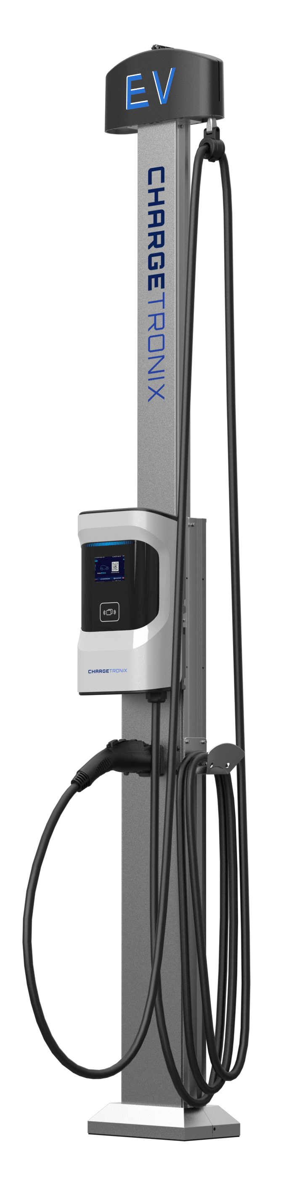
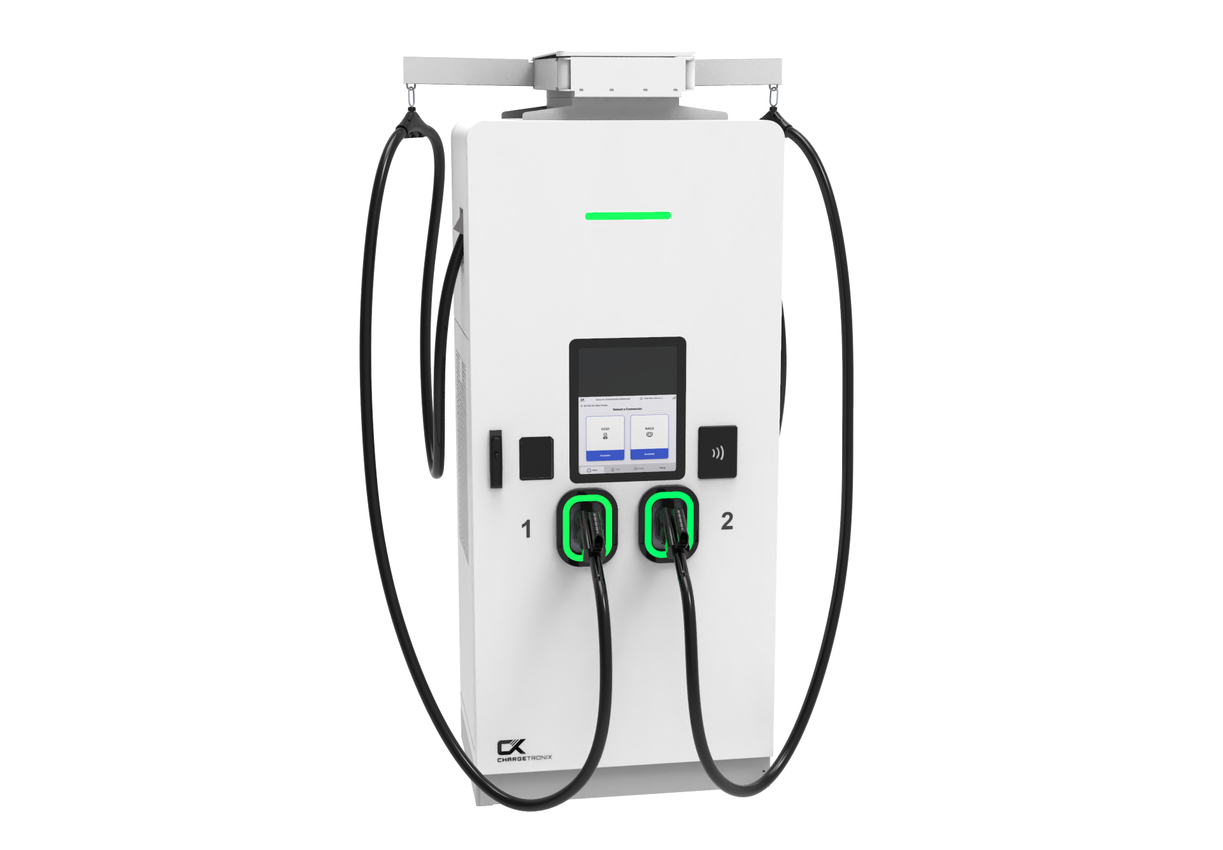
Recommended equipment schedule
Equipment | Qty | Nameplate rating |  | Modeled rating | Primary use
40A Dual Commercial L2 Charger (18' Cable with Modem) | 15 | 7.06 kW |  | Longer-dwell customer charging | Longer-dwell customer charging

Configuration narrative
The proposed configuration modernizes a proven retail charging location with higher-power DC fast charging, expanded Level 2 capacity, improved connector compatibility and a unified operating platform. The site will retain the customer convenience of both fast-turnover and longer-dwell charging while addressing the downtime and failed-session patterns visible in the historical data.

Modernizing your chargers will further establish your site as a reliable charging destination as EV charging technology evolves, increasing traffic and customer satisfaction.
As the I-5 Fwy is one of the most driven roads along the West Coast, tourists and city folks combined will see your DC fast chargers as the most efficient place to stop and charge their vehicle while they grab a bite to eat and continue on with their travels.
 | FINAL SUBMITTAL: Final connector type, cable length, payment hardware, certifications, enclosure rating, communications, accessibility requirements and product warranty will be confirmed in the approved equipment submittal.
6A |  | CHARGING EQUIPMENT DETAILS  Continuation of Section 6

Level 2 charging
Specification | Proposal field
Model / SKU | CTX-C40-240-2
Quantity / ports | 15 single-port units
Electrical rating | 32A
Power | 7.06 kW modeled
Mounting / cable management | Pedestal and cable-management configuration as scheduled
Payment and access | EVOLV app and guest payment
DC fast charging
Specification | Proposal field
Models / quantities | none
Modeled fleet rating | 0.00 kW average
Connector configuration | CCS1 and NACS / dual connector as selected
Payment | Integrated payment method and EVOLV configuration
Cable management | Cable retractors on each Level 3 cord
NACS connector addition
The modernization replaces legacy CHAdeMO capability with NACS / Tesla connector capability on the Level 3 chargers while retaining CCS1 as selected. This expands access for a growing share of North American EVs and reduces reliance on adapters for compatible vehicles.

7 | RETURN ON INVESTMENT

Initial investment
With an initial investment of $110,130.09, the modelled cashflow does not turn positive within 5 years. Break-even depends on utilisation rising above the assumptions used here.
Initial investment costs
Cost category | Customer price
Equipment Purchase Invoice | $110,130.09
Charger Hardware | $29,287.50
Parts Warranty | $42,728.25
EVOLV & Commissioning Subtotal | $35,991.00
Sales Tax on Chargers | $2,123.34
Main Distribution Switchgear | $0.00
Grand Total | $110,130.09
Total After Discount | $110,130.09
Projected ROI after 5 years
Projected ROI over 5 years | Value
Total Costs Upfront | -$110,130.09
Carbon Credits | $20,585.46
EVSE Revenues | $84,140.89
Net Revenues | -$5,403.74
QUALIFICATION: Modeled tax incentives and environmental credits are subject to eligibility, documentation, program rules, credit ownership, market pricing and applicable tax advice.

7A | CONSOLIDATED 5-YEAR CASHFLOW  Continuation of Section 7

How the model calculates break-even
With the initial investment of $110,130.09, the table below tracks cumulative cashflow across 5 years. Cumulative cashflow remains negative throughout, ending the period at -$5,404.
Year | Annual cashflow | Cumulative
0 | -$110,130 | -$110,130
1 | $17,231 | -$92,899
2 | $18,870 | -$74,029
3 | $20,714 | -$53,315
4 | $22,789 | -$30,526
5 | $25,123 | -$5,404

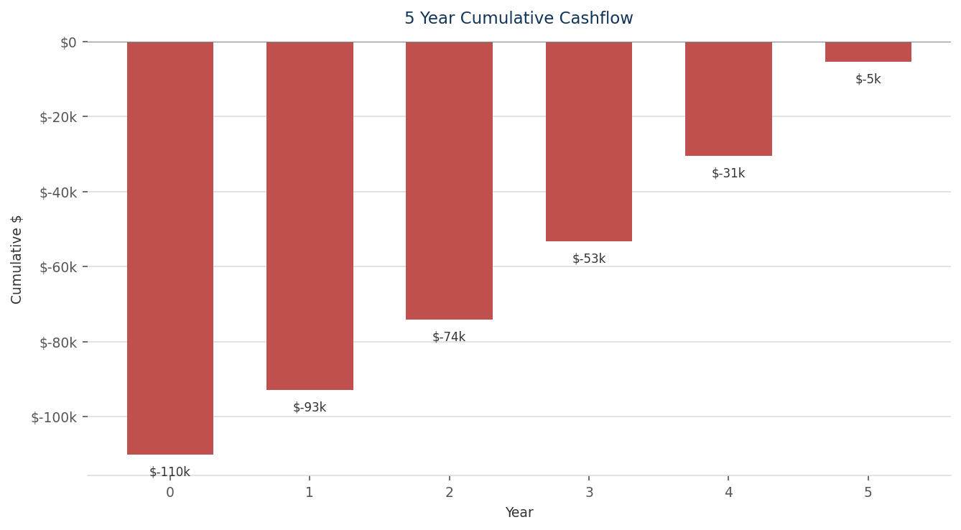
Modeled cumulative project cashflow

7B | CHARGER REVENUE CASHFLOW  Continuation of Section 7

Year | Annual cashflow | Cumulative
0 | -$110,130 | -$110,130
1 | $13,114 | -$97,016
2 | $14,753 | -$82,263
3 | $16,597 | -$65,666
4 | $18,672 | -$46,995
5 | $21,006 | -$25,989
TABLE SCOPE: This table isolates modeled charger operating revenue and does not include carbon credits, federal tax benefits or other project value streams.

8 | RIP AND REPLACE SCOPE

This scope applies to removal and replacement of the existing charging equipment and integration with reusable infrastructure where field conditions allow. Confirmed reuse will be distinguished from items that remain subject to site verification and final engineering.
Rip-and-replace activities
Phase | Included activities | Key client decision / dependency
Site verification | Document existing equipment, conductors, breakers, panels, pads, bollards, network and ADA conditions | Access to site, as-builts and shutdown windows
Decommissioning | Lockout/tagout, disconnect, remove and stage existing charging equipment | Ownership, disposal and data-retention instructions
Reuse assessment | Test conductors, grounding, breakers, panels, conduit, foundations and communications | Approval of any reuse-related risk or exclusions
Retrofit work | Modify pads, conduit, conductors, protection, bollards, striping and signage as required | Final engineering and permitting
Installation and cutover | Install charging equipment, configure network and payment systems, test and energize | Utility availability and coordinated outage plan
Closeout | Commissioning report, photos, serial numbers, as-builts, training and warranty registration | Client acceptance and punch-list closure
Removal and disposal
Removed equipment will be handled in accordance with the final contract, including client direction regarding retention, recycling, return to the original equipment manufacturer, storage or disposal. Any data-retention or network decommissioning requirements will be completed before final removal.
Downtime and cutover plan
Zero Impact Energy will coordinate the sequence of decommissioning, installation, networking, testing and commissioning to reduce disruption. The final outage window, work hours, partial-service availability and customer communications will be confirmed after site verification, utility coordination and approved construction scheduling.

9 | ELECTRICAL AND CIVIL INFRASTRUCTURE SCOPE

Modeled cost categories
Category | Modeled amount | Description
Other / miscellaneous | $0 or project-specific | Permits, utility, paving, ADA and additional materials as applicable
SCOPE BASIS: Permitting, utility, engineering, paving and ADA work are included only to the extent expressly stated in the final scope and pricing. Additional requirements identified during design or field verification may require a written change order.

10 | EVOLV SOFTWARE AND PAYMENT OPERATIONS

EVOLV is the charging operations platform used to connect charging assets, manage driver access and payments, monitor performance and provide operating data. The platform configuration distinguishes software functions from field O&M services so the client understands what the platform does and what requires technician support.
Core platform functions  • Real-time charger status and fault visibility  • Driver access, payment and session management  • Pricing, grace-period and idle-fee configuration  • Utilization, energy, revenue and settlement reporting  • User, site and portfolio administration  • Open-protocol integration subject to equipment compatibility | Commercial configuration  • Number of ports and platform term  • Per-port monthly or annual fee  • Payment-processing and guest-payment fees  • Merchant-of-record and settlement timing  • Data ownership, retention and reporting access  • Support hours and escalation process
Modeled platform economics
Item | Modeled value | Commercial treatment
Network cloud service fee | $39.99 per port per month | Confirm current rate and included functions
Ports | 15 | Must match final installed and active port count
Annual platform cost | $7,198 | 13 x $39.99 x 12
Contract duration | 5 years | Subject to final contract term, renewal and termination rights
Modeled customer platform total | $35,991 | Reflected in current project pricing
Charger support and service
- Rapid remote diagnostics and issue resolution
- Localized U.S. support and consistent escalation
- Real-time system monitoring and performance visibility
- Phone and email support channels
- Extended service hours from 7 a.m. to 10 p.m.
- Tailored operator training sessions of approximately 2 to 3 hours

11 | OPERATIONS AND MAINTENANCE

What O&M means
Operations and maintenance is the ongoing process of keeping the charging site available, safe, connected, properly configured and economically productive after commissioning. O&M is broader than a parts warranty and broader than software monitoring. It combines remote operations, issue management and field service under a defined support model.
O&M function | What it includes | Current treatment
Remote monitoring | Status review, alerts, diagnostics and ticket creation | Included through EVOLV and selected service plan
Remote resolution | Resets, configuration, firmware and network troubleshooting | Included during support hours
Preventive maintenance | Inspection, cleaning, torque checks, filters, cables and safety review | Per final service plan and checklist
Corrective maintenance | Technician dispatch, diagnosis and repair | Per final service plan and response target
Parts logistics | RMA, spare parts, shipping and replacement coordination | Subject to warranty and parts coverage
Performance reporting | Uptime, faults, sessions, revenue and recurring-issue analysis | Monthly or quarterly as selected
Customer support | Driver or site-host support channels and escalation | Phone, email and platform channels
SERVICE FRAMEWORK: O&M is broader than the equipment warranty. Final responsibilities, response targets, preventive-maintenance frequency, labor coverage and exclusions will be governed by the executed service agreement.

12 | WARRANTY AND SERVICE COVERAGE

The project separates manufacturer equipment warranty, Zero Impact Energy service obligations, EVOLV platform support and any extended coverage. The final contract will identify parts, labor, shipping, field response, exclusions and the process for requesting service.
Coverage layer | Typical responsibility |  | Customer-facing treatment
Manufacturer parts warranty | OEM replacement of eligible failed components |  | Term, covered parts, exclusions, RMA and shipping stated in final warranty
Labor warranty | Installer correction of covered workmanship issues |  | Term, covered work and exclusions stated in contract
O&M service plan | Monitoring, preventive and corrective service |  | Hours, response targets, labor, travel and parts limits stated in service plan
Software support | Network and application support |  | Support hours, channels and escalation stated in EVOLV terms
Extended warranty | Additional equipment coverage after standard term |  | Price, term, deductible and exclusions stated if selected
2 years  STANDARD PARTS WARRANTY  Equipment basis | 5 years  MODELED SERVICE TERM  Subject to final agreement | $46,560  SERVICE / WARRANTY ALLOWANCE  Included in customer price |  | $24,750  LABOR ALLOWANCE  Current modeled amount
COVERAGE CONTROL: Final coverage is governed by the executed manufacturer warranty, service agreement and project contract. Where descriptions differ, the signed documents control.

13 | CARBON CREDITS AND ENVIRONMENTAL VALUE

There are two main types of Carbon Credits. Consumption (usage-based) credits are earned on every kWh your chargers actually dispense—roughly one metric ton of credits for every 3,500–4,500 kWh delivered—so they grow with site usage and apply to both Level 2 and Level 3 chargers. Capacity credits, formally called Fast Charging Infrastructure (FCI) credits, instead reward the charging capacity you install regardless of whether it's used. FCI applies only to public DC fast chargers (Level 3) rated 50 kW or more that were permitted on or after January 1, 2022 and are networked with real-time uptime reporting. FCI is designed to give sites predictable revenue for up to 10 years during their low-traffic early years, though it's first-come, first-served, capped statewide at 2.5% of California's fuel deficits, and a site stops qualifying for capacity credits once cumulative FCI revenue exceeds 1.5x the net cost of its capital expenditures (after grants).
Most site owners don't deal with CARB directly. They work with a registered aggregator (such as FuSE or Xpansiv) that handles charger registration, quarterly data reporting, verification, and credit sales, keeping a percentage of the revenue in exchange. Credit value ultimately depends on charger type, energy dispensed, reliable uptime, and accurate documentation—so the credits can meaningfully improve project economics, operating costs, maintenance, and future expansion, but only when the site is eligible and well-managed.
Credit values are calculated differently depending on charger type. Level 3 (fast) chargers are valued per unit according to their power rating, using a pre-calculated annual credit yield applied across the term of the agreement and breaks down to the number of chargers multiplied by the annual credit value multiplied by the number of years with current rates of $8,600 per year for the 100 kW class. Level 2 chargers, by contrast, are metered on actual energy consumption rather than a fixed per-unit rate, so the total kilowatt-hours delivered must be estimated from occupancy and charging speed: estimated monthly kWh multiplied by the credit value per kWh ($0.0045) multiplied by the number of months, where monthly kWh is derived as ports × occupancy rate × charging hours × 6.9 kW.

Required commercial terms
Topic |  | Proposal requirement
Program and eligibility |  | Identify the specific program and confirm the site and charging activity are eligible
Credit ownership |  | State whether the client, Zero Impact Energy, utility, financier or aggregator owns the credits
Registration and reporting |  | Identify who registers equipment, submits data and maintains records
Revenue sharing |  | State gross credit value, aggregator fees and net customer share
Price and volume assumptions |  | Show the assumed credit price, energy volume and sensitivity
Timing and risk |  | Explain issuance lag, market-price volatility, rule changes and non-guarantee
$218,460  MODELED 5-YEAR CREDITS  Workbook estimate | $8,600 / $4,300  LEVEL 3 MULTIPLIERS  Fixed model inputs |  | $0.0045  LEVEL 2 FACTOR  Applied to consumption | Subject to validation  ELIGIBILITY STATUS  Not guaranteed
PROGRAM QUALIFICATION: The modeled carbon-credit amount is not contracted revenue. Eligibility, methodology, ownership, aggregator fees, pricing and reporting responsibilities must be documented before credits are treated as a committed customer benefit.

14 | INCENTIVES, TAX BENEFITS AND FINANCING

Potential capital-stack components
Component | How to present it | Required qualification
Utility or public incentive | Estimated award and eligible cost categories | Subject to application, reservation, funding and compliance
Federal tax credit | Modeled percentage and eligible basis | Taxpayer eligibility and tax counsel confirmation
Environmental credits | Projected operating-period benefit | Program eligibility, ownership and market pricing
Equipment financing | Term, rate, monthly payment and total interest | Lender approval, documentation and final pricing
Customer capital | Upfront contribution and payment milestones | Contractual payment schedule
Illustrative financing example
$272,023  FINANCED AMOUNT  Modeled full project | 8.39%  INTEREST RATE  Model input | 60 months  TERM  Five years | $5,567  MONTHLY PAYMENT  Total interest $61,970
Illustrative tax-credit history
When Congress passed the OBBBA in July 2025, it stripped the ITC from most technologies but deliberately spared batteries. After the passage of the One Big Beautiful Bill Act, 48E now applies exclusively to standalone energy storage projects — not to solar or wind as it once did. The timeline is generous: battery projects that begin construction before the end of 2033 still qualify for a 30% credit under Section 48E, after which the rate tapers down. So while solar and wind are racing a 2027 cliff, storage has most of a decade of runway.
The mechanics for a business: the base credit is 6 percent of eligible project costs, but it can increase to 30 percent if prevailing wage and apprenticeship requirements are met. On top of that, bonus adders can significantly increase your credit value — a +10% domestic content bonus when U.S. sourcing thresholds are met, a +10% energy community bonus for projects in qualifying areas, and a low-income bonus available through a competitive allocation program for qualifying projects under 5 MW. Critically for a charging site, unlike the prior version of the ITC, this credit does not require the storage system to be directly connected to or charged by a solar system — standalone batteries qualify on their own.
TAX QUALIFICATION: Tax-credit treatment is subject to taxpayer eligibility, placed-in-service timing, prevailing-wage and apprenticeship requirements, domestic-content rules, eligible-basis review and independent tax advice.

15 | PROJECT DELIVERY PLAN AND SCHEDULE

Phase | Typical duration | Key activities | Schedule dependencies
1. Validation | 1-3 weeks | Site walk, data review, equipment confirmation and commercial alignment | Site access and complete data
2. Engineering / utility | 4-16+ weeks | Design, utility coordination, permit package and plan check | Utility and AHJ response
3. Procurement | 6-20+ weeks | Equipment release, submittals and material procurement | Final design, deposit and availability
4. Construction | 1-8+ weeks | Civil, electrical, equipment installation and restoration | Permit, utility readiness and site access
5. Commissioning | 2-5 days | Networking, payment setup, testing, training and acceptance | Energization and communications
6. Operations | Ongoing | Monitoring, reporting, maintenance and optimization | Executed service agreement
Milestone schedule
Milestone | Target date | Owner | Status / notes
Proposal approval | Upon client authorization | Client / Zero Impact Energy | Pending
Site verification complete | To be scheduled | Zero Impact Energy | Pending
Design submitted | After site verification | Engineering | Pending
Permit / utility approval | Agency dependent | AHJ / utility | Pending
Equipment released | After approval and deposit | Zero Impact Energy | Pending
Construction complete | Per final project schedule | Zero Impact Energy / contractor | Pending
Commissioning and acceptance | Following installation | Joint | Pending
SCHEDULE BASIS: Schedule durations are planning ranges. The definitive schedule will be issued after utility requirements, permits, equipment availability, site conditions and client access constraints are confirmed.
Construction timeline
Due to the nature of this project, and the very slight relocation of the chargers, we are expecting this construction to take 3 to 4 weeks. The following Gantt chart shows the estimated timeline for completion.
Construction Schedule
Activity | Duration | Week 1 |  |  |  |  | S | S | Week 2 |  |  |  |  | S | S | Week 3 |  |  |  |  | S | S
Remove Chargers | 1 day
Demo Concrete Pads | 2 days
Trenching for Conduit | 2 days
Rerouting Conduits | 2 days
Forming Pads | 2 days
Rebar | 1 day
Pour Concrete | 1 day
Install New L3's | 1 day
Pull Wire | 2 days
Power up and commission | 1 day
Estimated construction sequence, shown in working days across four weeks
16 | DETAILED SCOPE OF WORK

Work package | Zero Impact Energy scope | Client / third-party scope
Project management | Coordinate project team, schedule, submittals, meetings and reporting | Provide timely decisions, access and a designated point of contact
Site verification | Field review of visible conditions and available documents | Provide as-builts, utility bills, title or site restrictions and known conditions
Engineering | Electrical, civil and structural design as stated in final scope | Review and approve design criteria; provide owner standards
Utility / permitting | Applications, coordination and plan check as stated in final scope | Execute owner agreements and pay owner-direct fees as stated
Procurement | Supply approved charging equipment and listed accessories | Approve substitutions and release milestones
Construction | Perform stated demolition, civil, electrical and restoration work | Provide work area, shutdown approval and site coordination
Software / payments | Configure EVOLV, pricing, access and reporting | Provide merchant, banking, branding and policy information
Commissioning | Test equipment, network, payment and basic operations | Attend acceptance and identify authorized users
Training / closeout | Provide operational training and closeout records | Participate in training and maintain site contacts
O&M | Provide the selected support package after acceptance | Provide access, report damage and follow operating procedures
Charger and battery-storage integration
When connecting chargers into currently existing battery storage systems, there are two options on how to tie the chargers into the system.
Grid-parallel operation
Grid-parallel operation is the configuration that accounts for nearly all real installations, and it's where the economics actually live. The charger draws from the grid as its primary source, and the battery contributes during high-demand windows — shaving the peak rather than carrying the load. This solves two distinct problems. First, it can prevent a utility service upgrade: under NEC 705.13, a listed Power Control System can be used to cap total current on the service so a 200-amp panel can host chargers whose nameplate draw would otherwise exceed it, with the battery and the PCS jointly ensuring the service never gets overloaded. Avoiding a transformer upgrade and the associated utility timeline is frequently worth more than the energy savings. Second, it attacks demand charges, which in California commercial rates can run $20 to $35 per kW and are set by a single 15-minute peak. A 150 kW fast charger firing once during the monthly peak window can add several thousand dollars to a bill; a battery that discharges into that spike flattens it. Worth checking the rate schedule first, though — PG&E's BEV rates and SCE's TOU-EV-8/9 already suppress or eliminate demand charges for qualifying EV loads, which can substantially shrink the arbitrage the battery was going to capture.
Battery-only operation
Battery-only operation — the charger fed exclusively from storage, with no grid contribution during the charging session — is technically achievable but constrained in ways that are easy to underestimate. Two hard requirements: the inverter must be grid-forming, not merely grid-following, and the site needs a microgrid interconnect device or transfer switch to cleanly separate from the utility. Most commercial storage inverters sold as grid-tied are grid-following only; they synchronize to an existing AC waveform and shut down when it disappears. Such a system cannot power a charger during an outage at all, regardless of state of charge. This is the single most common surprise in these projects, and it's worth confirming from the inverter's listing before designing anything around it.

17 | FINANCING OPTIONS

De Lage Landen financing
De Lage Landen (DLL), is a wholly owned Rabobank Group subsidiary established in 1969 and based in Eindhoven, the Netherlands. It is an international asset finance organization with an active portfolio exceeding €47 billion across more than 25 countries. The company's model centers on vendor finance, meaning it embeds itself in the supply chain rather than competing for retail borrowers: DLL builds asset-based financing programs with manufacturers, dealers, distributors, and resellers, delivered at their points of sale and structured to follow equipment across its entire technical life. Coverage spans through agriculture, construction, energy transition, food, healthcare, industrial, technology, transportation, and workplace equipment. DLL holds credit institution status under the EU's Capital Requirements Regulation and delivers business through country-level entities while serving several European markets through branches under its passporting rights. Electrification has become a visible strategic priority: DLL works with Zero Impact Energy to provide their clients with the option to finance their clean energy construction process.
DLL schedule
The amortization schedule finances $110,130.09 at 8.39% over 5 years, 60 monthly payments of $2,253.65 beginning September 1, 2026. Total interest over the term is $25,089.11.
Facility input | Value
Loan amount | $110,130.09
Annual interest rate | 8.39%
Loan period | 5 years
Payments per year | 12
Modeled start date | August 1, 2026
Optional extra payments | None modeled
Loan summary | Value
Scheduled payment | $2,253.65
Scheduled number of payments | 60
Actual number of payments | 60
Total early payments | None modeled
Total interest | $25,089.11

17A | MODELED MONTHLY CASHFLOW  Continuation of Section 17

Across the 60-month term the model shows $118,199.47 of charging profit and -$110,130.09 of carbon credits against $135,219.20 of loan payments, a net of -$127,150. Monthly net cashflow starts at -$2,554 and reaches -$1,630 by the final month as the modelled revenue escalates.
FINANCING QUALIFICATION: Financing is subject to lender credit approval, documentation, final pricing, equipment eligibility, transaction structure and closing conditions.

17B | 60-MONTH FINANCING CASHFLOW  Appendix to Section 17

Months 1 through 25
Month | Loan payment | Carbon credits | EVSE profit | Net monthly cashflow
1 | $2,253.65 | -$1,835.50 | $1,535.16 | -$2,554.00
2 | $2,253.65 | -$1,835.50 | $1,535.16 | -$2,554.00
3 | $2,253.65 | -$1,835.50 | $1,535.16 | -$2,554.00
4 | $2,253.65 | -$1,835.50 | $1,535.16 | -$2,554.00
5 | $2,253.65 | -$1,835.50 | $1,535.16 | -$2,554.00
6 | $2,253.65 | -$1,835.50 | $1,535.16 | -$2,554.00
7 | $2,253.65 | -$1,835.50 | $1,535.16 | -$2,554.00
8 | $2,253.65 | -$1,835.50 | $1,535.16 | -$2,554.00
9 | $2,253.65 | -$1,835.50 | $1,535.16 | -$2,554.00
10 | $2,253.65 | -$1,835.50 | $1,535.16 | -$2,554.00
11 | $2,253.65 | -$1,835.50 | $1,535.16 | -$2,554.00
12 | $2,253.65 | -$1,835.50 | $1,535.16 | -$2,554.00
13 | $2,253.65 | -$1,835.50 | $1,727.05 | -$2,362.11
14 | $2,253.65 | -$1,835.50 | $1,727.05 | -$2,362.11
15 | $2,253.65 | -$1,835.50 | $1,727.05 | -$2,362.11
16 | $2,253.65 | -$1,835.50 | $1,727.05 | -$2,362.11
17 | $2,253.65 | -$1,835.50 | $1,727.05 | -$2,362.11
18 | $2,253.65 | -$1,835.50 | $1,727.05 | -$2,362.11
19 | $2,253.65 | -$1,835.50 | $1,727.05 | -$2,362.11
20 | $2,253.65 | -$1,835.50 | $1,727.05 | -$2,362.11
21 | $2,253.65 | -$1,835.50 | $1,727.05 | -$2,362.11
22 | $2,253.65 | -$1,835.50 | $1,727.05 | -$2,362.11
23 | $2,253.65 | -$1,835.50 | $1,727.05 | -$2,362.11
24 | $2,253.65 | -$1,835.50 | $1,727.05 | -$2,362.11
25 | $2,253.65 | -$1,835.50 | $1,942.93 | -$2,146.22

17C | 60-MONTH FINANCING CASHFLOW  Appendix to Section 17

Months 26 through 50
Month | Loan payment | Carbon credits | EVSE profit | Net monthly cashflow
26 | $2,253.65 | -$1,835.50 | $1,942.93 | -$2,146.22
27 | $2,253.65 | -$1,835.50 | $1,942.93 | -$2,146.22
28 | $2,253.65 | -$1,835.50 | $1,942.93 | -$2,146.22
29 | $2,253.65 | -$1,835.50 | $1,942.93 | -$2,146.22
30 | $2,253.65 | -$1,835.50 | $1,942.93 | -$2,146.22
31 | $2,253.65 | -$1,835.50 | $1,942.93 | -$2,146.22
32 | $2,253.65 | -$1,835.50 | $1,942.93 | -$2,146.22
33 | $2,253.65 | -$1,835.50 | $1,942.93 | -$2,146.22
34 | $2,253.65 | -$1,835.50 | $1,942.93 | -$2,146.22
35 | $2,253.65 | -$1,835.50 | $1,942.93 | -$2,146.22
36 | $2,253.65 | -$1,835.50 | $1,942.93 | -$2,146.22
37 | $2,253.65 | -$1,835.50 | $2,185.80 | -$1,903.36
38 | $2,253.65 | -$1,835.50 | $2,185.80 | -$1,903.36
39 | $2,253.65 | -$1,835.50 | $2,185.80 | -$1,903.36
40 | $2,253.65 | -$1,835.50 | $2,185.80 | -$1,903.36
41 | $2,253.65 | -$1,835.50 | $2,185.80 | -$1,903.36
42 | $2,253.65 | -$1,835.50 | $2,185.80 | -$1,903.36
43 | $2,253.65 | -$1,835.50 | $2,185.80 | -$1,903.36
44 | $2,253.65 | -$1,835.50 | $2,185.80 | -$1,903.36
45 | $2,253.65 | -$1,835.50 | $2,185.80 | -$1,903.36
46 | $2,253.65 | -$1,835.50 | $2,185.80 | -$1,903.36
47 | $2,253.65 | -$1,835.50 | $2,185.80 | -$1,903.36
48 | $2,253.65 | -$1,835.50 | $2,185.80 | -$1,903.36
49 | $2,253.65 | -$1,835.50 | $2,459.02 | -$1,630.13
50 | $2,253.65 | -$1,835.50 | $2,459.02 | -$1,630.13

17D | 60-MONTH FINANCING CASHFLOW  Appendix to Section 17

Months 51 through 60
Month | Loan payment | Carbon credits | EVSE profit | Net monthly cashflow
51 | $2,253.65 | -$1,835.50 | $2,459.02 | -$1,630.13
52 | $2,253.65 | -$1,835.50 | $2,459.02 | -$1,630.13
53 | $2,253.65 | -$1,835.50 | $2,459.02 | -$1,630.13
54 | $2,253.65 | -$1,835.50 | $2,459.02 | -$1,630.13
55 | $2,253.65 | -$1,835.50 | $2,459.02 | -$1,630.13
56 | $2,253.65 | -$1,835.50 | $2,459.02 | -$1,630.13
57 | $2,253.65 | -$1,835.50 | $2,459.02 | -$1,630.13
58 | $2,253.65 | -$1,835.50 | $2,459.02 | -$1,630.13
59 | $2,253.65 | -$1,835.50 | $2,459.02 | -$1,630.13
60 | $2,253.65 | -$1,835.50 | $2,459.02 | -$1,630.13

18 | TERMS, PROPOSAL VALIDITY AND ACCEPTANCE

Non-binding proposal disclaimer
This proposal is provided for evaluation, budgeting and scope-alignment purposes unless expressly incorporated into a definitive agreement. Pricing, schedule, incentives and projections are based on the information and assumptions identified in this document and may change following final engineering, site investigation, utility review, permitting, equipment availability, financing approval or other project-development findings. No contractual obligation arises until authorized representatives execute the applicable agreement, statement of work and commercial terms.
Revenue and incentive disclaimer
Utilization, revenue, energy cost, uptime, tax benefits, environmental credits and payback are projections rather than guarantees. Actual results will depend on driver demand, pricing, equipment availability, utility rates, operations, program rules and other factors outside Zero Impact Energy control. The client should obtain independent tax, legal and accounting advice.
Acceptance to proceed to definitive agreement
Field | Entry
Client legal name
Title | Owner
Signature
Date
This acknowledgment confirms the client’s intent to proceed with final scope development and contract preparation. It is not a notice to proceed unless expressly stated in the definitive agreement.

